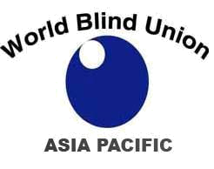
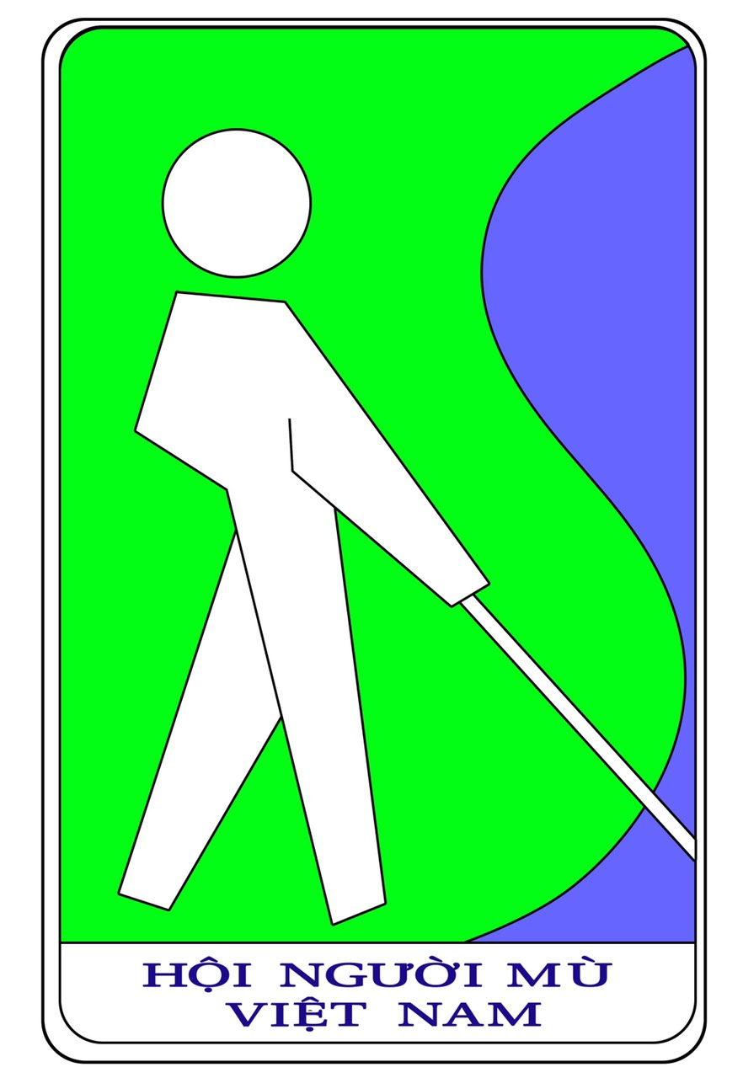

30 April, 2023
Re: The 16th World Blind Union - Asia Pacific Regional Massage Seminar

Dear Friends,
To promote the employment opportunities of visually impaired masseurs, strengthen the exchange and cooperation in blind massage among countries/regions and to enhance the development of blind massage in the Region, Vietnam Blind Association (VBA) is going to host the 16th World Blind Union Asia Pacific (WBUAP) Regional Massage Seminar which will take place in Hanoi, Vietnam on 7-9 September, 2023.
The theme of the Seminar is “Promoting Sustainable Collaboration on Research, Training and Service Quality on Massage”. Apart from reports and scientific presentations, this event will provide an opportunity for participants to share massage skills through hands-on demonstrations.
You and your organization’s members are cordially invited to participate in this seminar. It will be held at International Convention Center located in Hanoi - the capital of a thousand years of civilization of Vietnam. It is about 45 minutes from Noi Bai Airport and next to Ho Chi Minh Mausoleum as well as Ba Dinh Square.
Registration fee for participants and accompanying persons/personal assistants are the same at US$250 per person. Registration fee covers lunches and tea breaks on 7-9 September, Welcome dinner on 7th September and Gala dinner on 9th September, 2023. The registration fee also covers conference materials, use of radio transceivers for translation; shuttle bus service to and from the airport and from other hotels to the seminar venue as well as site visits. Delegates will be responsible for their own expenses during the Seminar, including registration fee, round-trip air fare, hotel accommodation, insurance, dinner for 8th September, meals for 6th September and 10th September 2023.
Registration will begin in 15th May, 2023 and deadline for registration will be on 1st July, 2023. Registration will be accepted on a first-come-first served basis. Once the capacity is full, registration will be closed. Therefore, you are

advised to register as soon as possible. All participants are expected to arrive in Hanoi on 6 September 2023. Please fill in the Registration Form at the Google form at:
https://docs.google.com/forms/d/e/1FAIpQLSdLdBH4a8shy3PSCEDbmaCXmPHUPg1EBYgfNtru_HU874o3Vg/viewform?usp=share_link
For more details of the Seminar, registration and the list of hotels, please visit our website at www.16thseminar.vn
We sincerely hope that through the interaction at the Seminar, we can adopt a statement geared towards the advancement of the blind massage industry. We look forward to your support, contribution and participation in this Seminar.
Thank you.

Your sincerely,

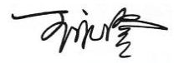

Wang Yongcheng Pham Viet Thu
Chairman Chairman of Organizing Committee
WBUAP Regional Massage Commission 16th WBUAP Regional Massage Seminar
President of Vietnam Blind Association

